10. Introduction, Instance Operators & Instance Operators Demo

Slide 21

There are static operators which don’t actually work on chain of data which sort of exist and there general purpose is to conveniently help us create new observable.

Slide 22

Instance operator consume data from an observable stream and transform it. But original data stream is not modified.

Code-

var numObservable = new Rx.Observable(observer => {

observer.next(7);

observer.next(13);

observer.next(17);

observer.next(19);

observer.next(23);

});

var scanned = numObservable

.startWith(0)

.scan((acc, v) => acc+v);

scanned.subscribe(e => console.log(e + "is a Sum"));

numObservable.subscribe(e => console.log(e + "is a number"));

out put –

here we used startWith operator to give initial value to accumulator.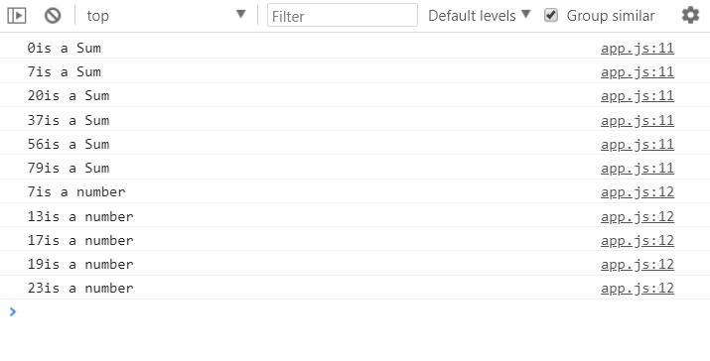

By using scan we created new observable stream but original observable stream is unchanged.

11)Static Operators & Static Operators Demo

Here we used some operators like create to create a observable from scratch.